**NAME…………………………………………………………..ADM NO: …………….CLASS……………**

**SCHOOL………………………………………………………………………………………………………..**

**SULIMO JOINT MOCK**

***Kenya Certificate of Secondary Education***

**231/2**

**BIOLOGY**

**PAPER 2**

**THEORY**

**JULY/ AUGUST, 2024**

**TIME: 2 HOURS**

**INSTRUCTIONS TO CANDIDATES**

1. Write your name, class and index Number in the spaces provided.
2. This paper consists of **TWO** sections. **A** and **B**
3. Answer **ALL** questions in section as in the spaces provided
4. In section B answer **question 6 (compulsory)** and **EITHER** question **7** or **8** in the spaces provided after question 8.

For examiner’s use only

|  |  |  |  |
| --- | --- | --- | --- |
| Section | Question | Maximum score | Candidates score |
| A | 1 | 8 |  |
| 2 | 8 |  |
| 3 | 8 |  |
| 4 | 8 |  |
| 5 | 8 |  |
| B | 6 | 20 |  |
| 7 | 20 |  |
| 8 | 20 |  |
| Total |  | 80 |  |

**SECTION A (40 MARKS)**

1.The diagram bellow shows a root system of a certain plant.

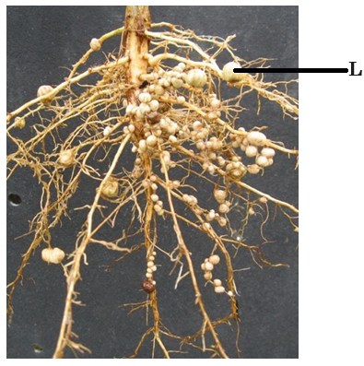

1. (i). Name structure L(1mark) *Root nodule*

(ii). Explain briefly the significance of having structure L in the root system of the plant represented above.(1mark) *Provide shelter and nutrients to the bacteria*

(b). (i) Name the organism found in the structure L. (1mark) *Rhizobium bacteria*

(ii). Explain the relationship between the organism named in b (i) above and the plant. (2marks)

*Symbiosis*

*The bacteria fixes nitogen into the soil while obtaining shelter and nutrients from the plant*

(c). With a reason state the class to which the plant represented in the diagram belong. (2marks)

Class *Dicotyledonae*

Reason *Has a tap root system*

(d). How do the structure labeled L compare in plant of the same species growing in fertile and poor soils. Explain. (2marks) *Plants growing in fertile soils have fewer root nodules than plants growing in poor soils. This is because fertile soils have sufficient amount of nitrogen hence no need for bacteria.*

2. In an family, the mother is blood group A while the father is blood group B. they had two children one with blood group B and the other with blood group O.

(a). Determine the genotypes of the parents. (2marks)

Mother *AO*

Father *BO*

b)Using a genetic cross show the possible genotypes of their children. (4marks)

*Parental genotype BO × AO*

*Gametes*

*Fusion*

*F1 generation genotype AB BO AO OO*

c)What is the probability of their third child having Blood group O? (1mark) *1/4 OR 25%*

d)Inheritance of blood group show multiple allelism.Give a reason .(1mark)

*It is controlled by three alleles ; A, B and O*

3. The changes that take place during the menstrual cycle in women is represented as shown below.

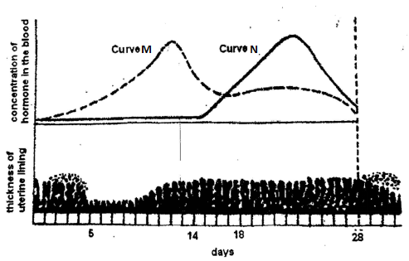

1. Name the hormones whose concentrations are represented by curves M and N. (2marks)

M *Oestrogen*

N *Progesterone*

1. State the effects of the hormones named in (a) above on the lining of the uterus. (2marks)

M *Stimulates healing and repair of the endometrium*

N *Stimulates thickening of the endometrium*

1. i)Which hormone is released by the pituitary gland in high concentration on the 14th day of the menstrual cycle. (1mark) *Luteinising hormone*

ii)State the function of the hormone named in c (i) above.(1mark)

*Stimulates the mature Graafian follicle to release an ovum (ovulation)*

*Stimulates the remains of Graafian follicle to change into corpus luteum*

*Stimulates the corpus luteum to secrete progesterone*

1. State 2 roles of testosterone (2marks)

*Stimulates development of secondary sexual characteristics in males*

*Stimulates sperm production*

4.Experiment to show that oxygen is used up during respiration

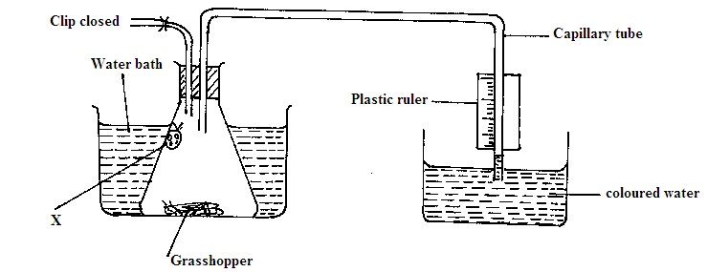

1. Name the substance labeled X and state its role ( 2marks)

Name *Potassium hydroxide/ Sodium hydroxide solution*

Role *To absorb carbon (iv) oxide gas*

1. Explain why the coloured water rose in the capillary tube ( 3marks)

*The grasshopper uses oxygen during respiration producing carbon (iv) oxide . Potassium hydroxide solution absorbs carbon (iv) oxide produced creating a partial vacuum. The coloured water rises to occupy the partial vacuum created.*

1. Explain the use of the closed clip ( 1 mark)

*To prevent entry of air*

1. Name two factors that determines the value of Respiratory quotient ( 2marks)

*Type of respiratory substrate*

*Type of respiration*

5.Form two students subjected an orange plant growing outside the laboratory to the following;

i) Selected two sized leaves and gently brushed them clean on both sides.

ii) Placed two strips of dry cobalt (ii) chloride paper on both sides of each leaf and opposite each other and covered the cobalt(ii) chloride papers with cello-tape. They observed the time taken for any colour change to occur and recorded the following.

|  |  |  |
| --- | --- | --- |
| Side of leaf | Upper epidermis | Lower epidermis |
| Time taken | 5 minutes | 2 minutes |

Use the above information to answer the following questions.

1. i) What was the aim of the above experiment. (1mk)

*To investigate the difference in rate of transpiration on different leaf surfaces*

ii) What was the purpose of brush cleaning the leaf (1mk)

*To remove dust particles*

iii) What was the role of cello-tape in this experiment? (1mk)

*To prevent water vapour from reacting with the cobalt (ii) chloride paper*

1. i) What was the original colour of dry cobalt chloride paper. (1mk)

*Blue*

ii) What colour change did the students observe? (1mk)

*The blue cobalt (ii) chloride paper turned pink faster on the lower side than on the upper side*

1. ) Explain the difference in time taken for the colour change observed. (3mks)

*It took less time for the cobalt(ii) chloride paper on the lower side to turn pink.There are more stomata on the lower side than on the upper side to reduce the rate of transpiration.*

**SECTION B (40 MARKS)**

1. In a study on immune response, two groups of mice were used. Sheep blood was introduced into both groups of the mice. One group was given 5 doses of a drug Tinorcodine prior to vaccination.The second group was not treated with Tinorcodine prior to vaccination.Blood was collected from each group every three days for one month and the quantities of antibodies determined. The results were as shown in the table below.

|  |  |  |
| --- | --- | --- |
| ***Number of days after immunization*** | ***Antibodies produced after immunization*** | |
|  | ***Tinocordine treated mice*** | ***Non-Tinocordine treated mice*** |
| 3 | 15 | 5 |
| 6 | 20 | 5 |
| 9 | 30 | 15 |
| 12 | 60 | 25 |
| 15 | 122 | 30 |
| 18 | 250 | 30 |
| 21 | 122 | 30 |
| 24 | 60 | 30 |
| 27 | 37 | 22 |
| 30 | 27 | 5 |

(a)Plot graphs using the same axes of antibodies produced after immunization against number of

days after immunization.(8marks)



b)Determine the rate of antibody production between day 13 and 17 in the Tinorcodine treated mice.(2marks)

c)Account for the difference in the concentration of antibodies in the two groups of mice. (3marks)

*The concentration of antibodies is higher in mice injected with Tinorcodine than the ones not injected.Tinorcodine injection triggers the body to produce its own antibodies . When the vaccine is introduced, the body produces more antibodies since the memory cells still recognizes how to generate the antibodies against the antigens.*

d)What type of immunity will be developed by the mice?(1mark)

*Active artificially acquired immunity*

1. Name one disease whose spread is controlled by vaccination in human beings. (1mark)

*Poliomyelitis,measles, yellow fever, Covid19*

1. State 3 ways of controlling HIV/AIDS. (3marks)

*Avoid unprotected sexual intercourse with an infected person*

*Avoid sharing sharp objects with infected person*

*Avoid deep kissing with an infected person*

*Screening of blood before transfusion*

1. State two other ways of controlling highly infectious diseases apart from vaccination. (2marks)

*Quarantine*

*Isolation and treatment of infected people.*

1. a)Describe the mechanism of inhalation in man. (8marks)

*During inspiration,*

*External intercostal muscles contract, while internal intercostal muscles relax.*

*This causes the ribs to move upwards and outwards.*

*Diaphragm muscles contract, making it flatten from its dome shape.*

*All these movements results in an increase in volume of thoracic and decrease in pressure.*

*Atmospheric pressure being higher than pressure in thoracic cavity ,forces air into the lungs thorough the nose and the trachea, hence inflating the lungs.*

b)Describe the adaptations of aquatic plants to gaseous exchange.(6marks)

*Have aerenchyma tissues for buoyancy and gaseous exchange*

*Some have pneumatophores for gaseous exchange*

*Some have numerous stomata on the upper epidermis for gaseous exchange*

*Some plants have lenticels on the stem for gaseous exchange*

c) Describe how the brain regulates breathing.(6marks)

*The part of the brain that regulates the rate of breathing is the medulla oblongata. During exercise the rate of respiration increases and more carbon (IV) oxide; is produced. When blood reaches the brain, the carbon (IV) oxide triggers the medulla oblongata; to sends impulse to the intercostal muscles; and diaphragm; which responds appropriately;*

a)How is the leaf of a terrestrial plant adapted to perform its function? (10marks)

*The leaf has a flat and broad lamina to increase surface area for trapping sunlight energy for photosynthesis.*

*The leaf has numerous stomata through which carbon(IV) oxide diffuses into the leaf.*

*The leaf is thin to reduce the distance through which light and carbon (IV) oxide has to pass into the photosynthetic cells.*

*The palisade mesophyll cells contain numerous chloroplasts which contain chlorophyll molecules which trap sunlight energy for photosynthesis.*

*The palisade mesophyll is located on the upper surface to receive maximum sunlight.*

*The leaf has an extensive network of veins containing xylem which conducts water to the photosynthetic cells and phloem to transport manufactured food materials to other plant parts.*

*The epidermis and cuticle are transparent to allow light to penetrate to the photosynthetic cells.*

*The spongy mesophyll has numerous air spaces to allow circulation of gases to allow them diffuse efficiently to photosynthetic cells*

*Leaves are arranged in a regular manner on the stem to minimize overlapping and over shadowing to enable them to absorb maximum amount of light.*

b)Describe eye accommodation. (10marks)

***Accomodation of the eye to near objects***

*Cilliary muscles contract*

*Tension on suspensory ligaments reduces*

*Curvature of the lens increases*

*Light from the near object is greatly refracted by the lens*

***Accommodation of the eye to far (distant) objects***

*Ciliary muscle relax*

*This increases tension on suspensory ligaments*

*This stretches the lens reducing the curvature i.e lens becomes thinner and less bulgy.*

*Light rays from far objects are less refracted hence are focused on the retina*